1. **Environment Configuration**
   1. Install the required Android modules.

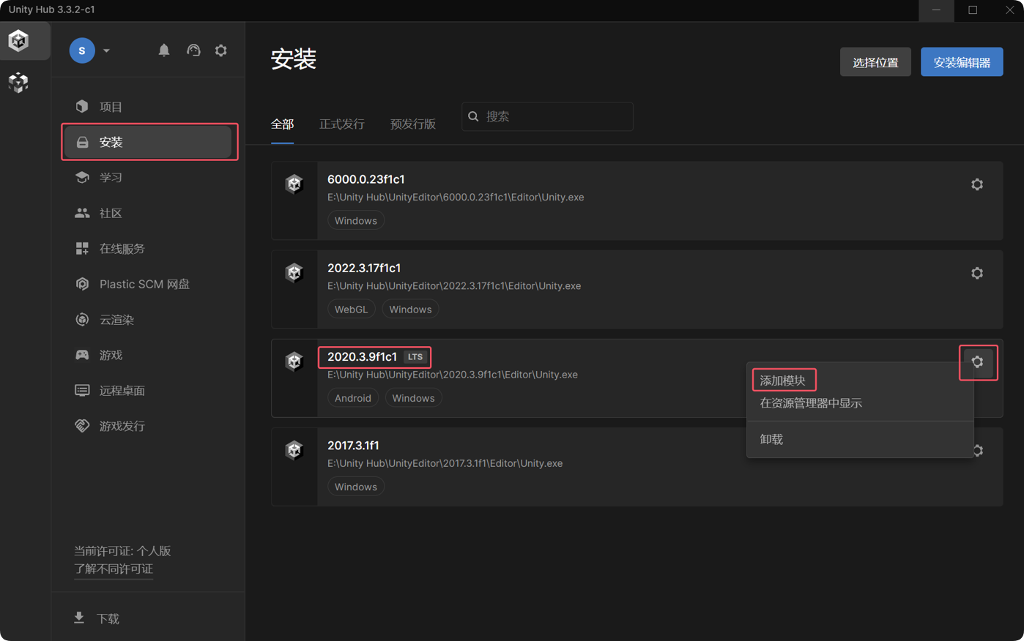

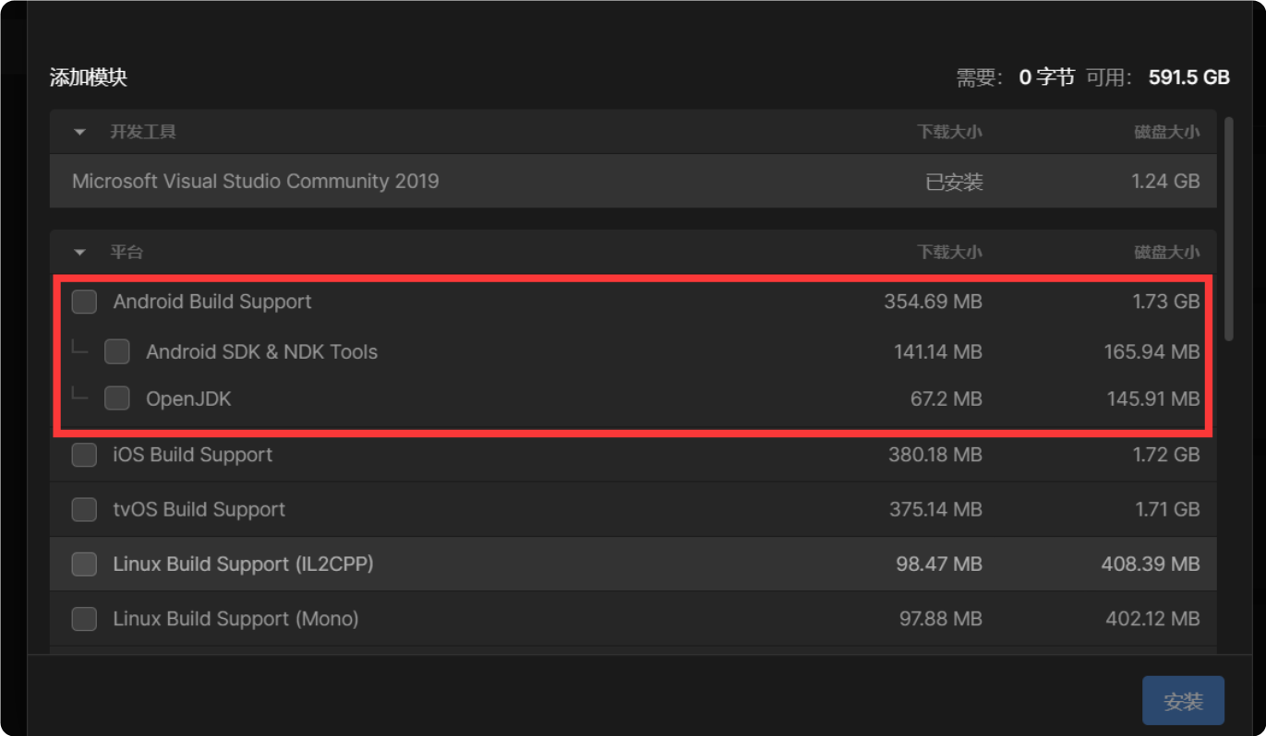

1.2 Path Configuration Unity Hub will automatically configure the path when installing the corresponding modules.

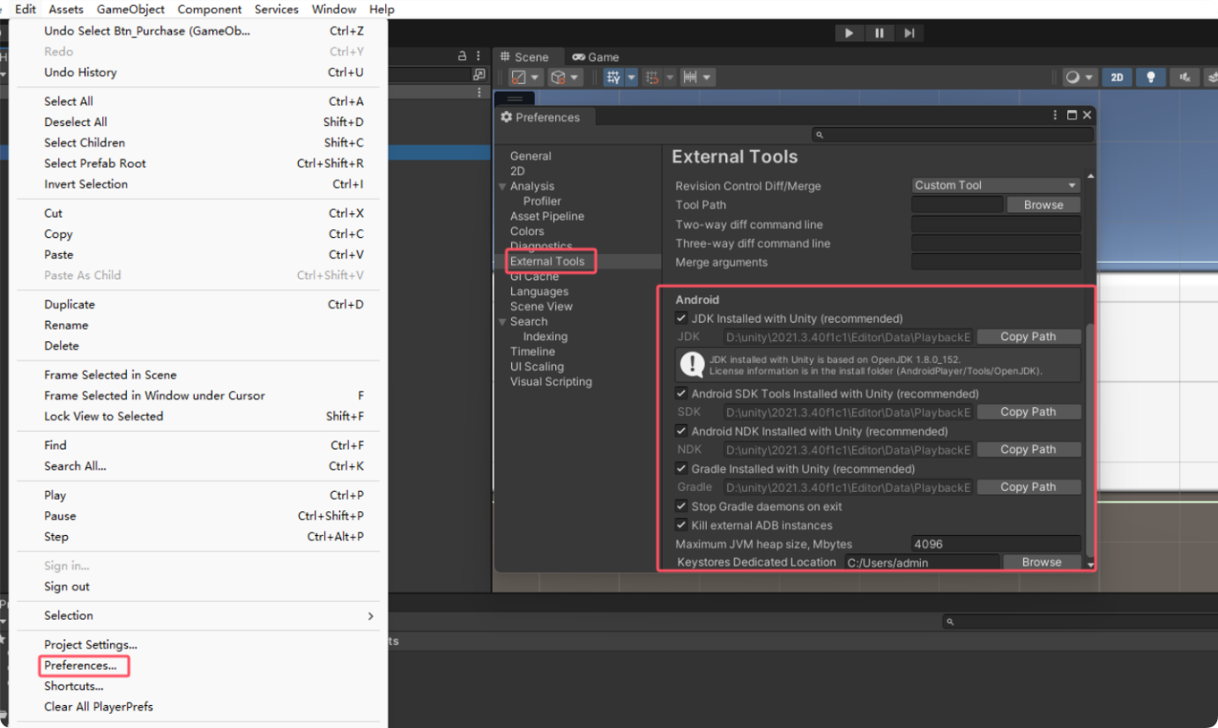

1. **Opening the Packaging Interface**

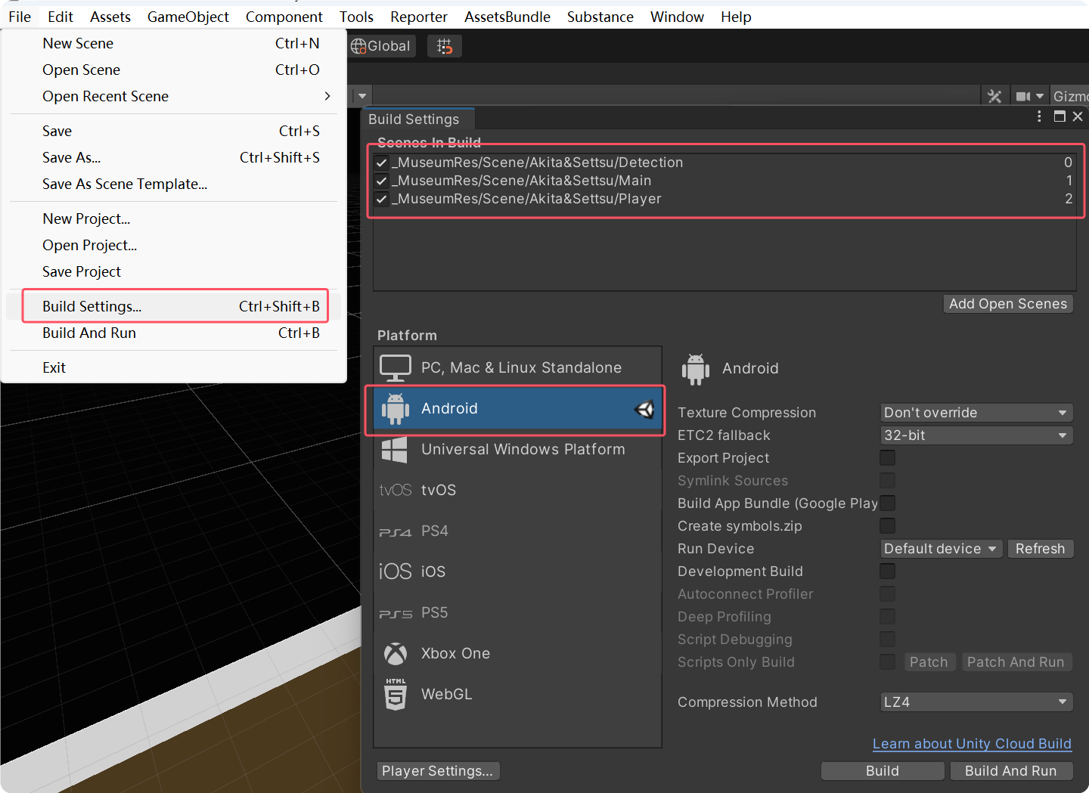

2.1 Project Configuration

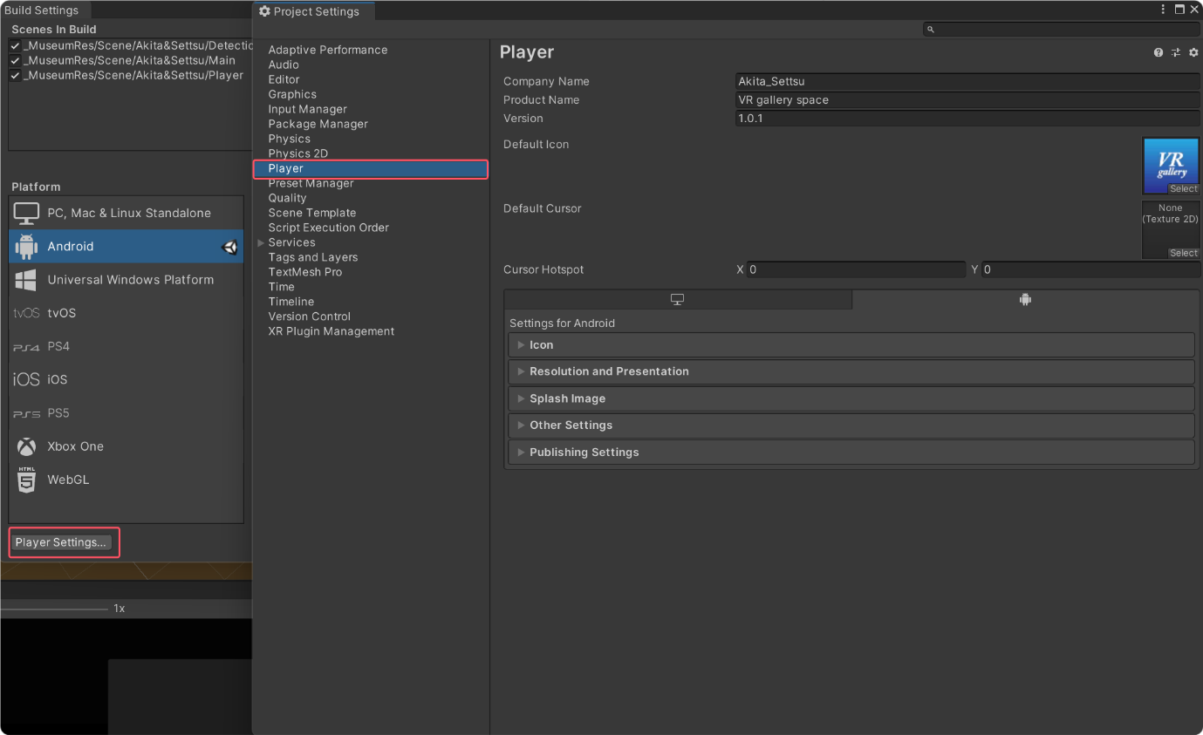

2.2 Configure company name, project name, and version number.

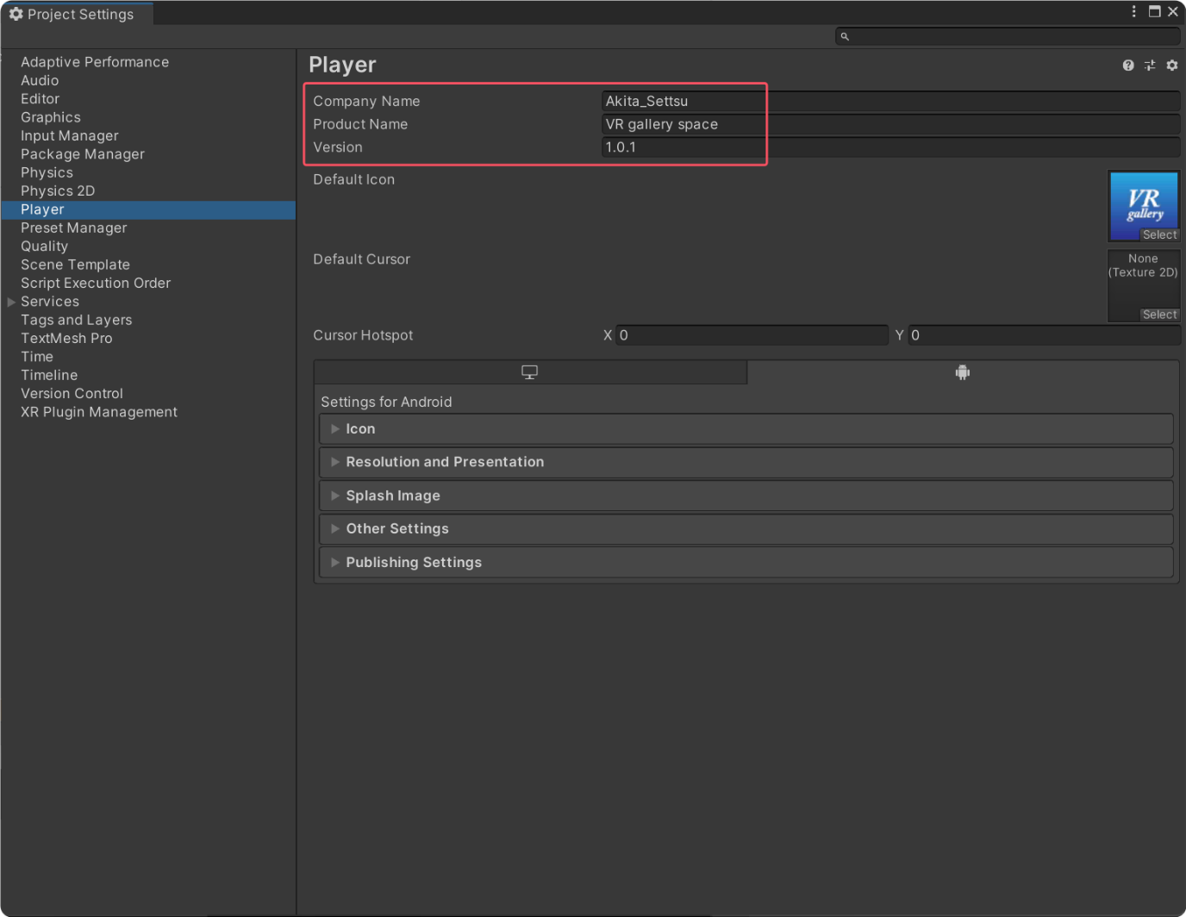

2.3 Configure the icon.

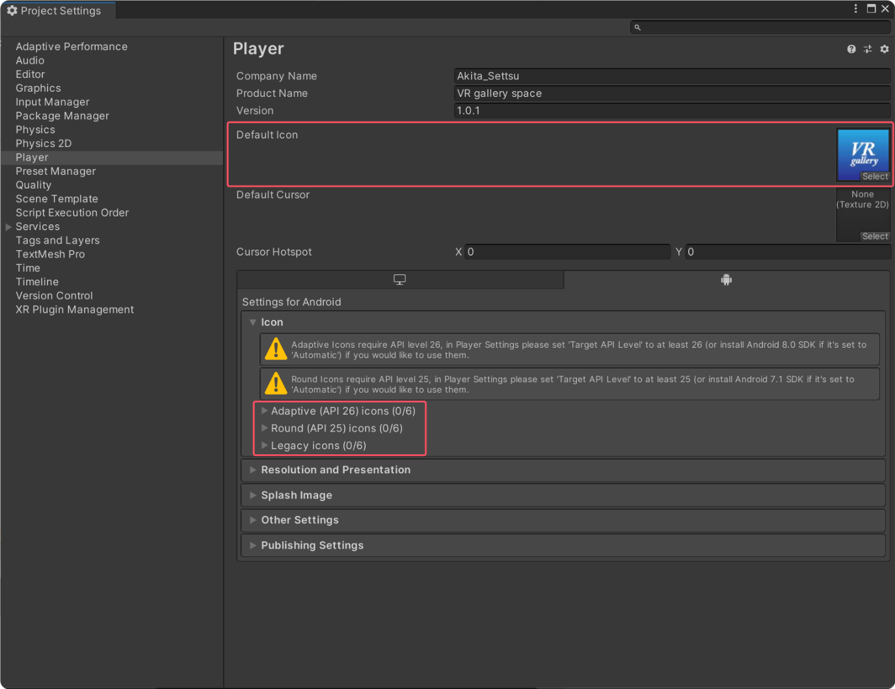

2.4 Version Settings

Set the API according to the Android system version.

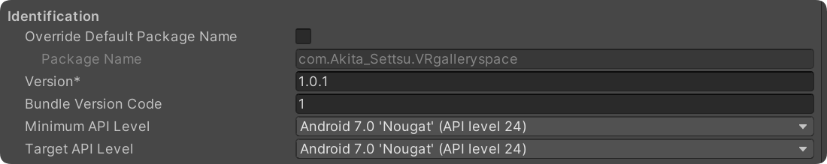

2.5 Key Settings

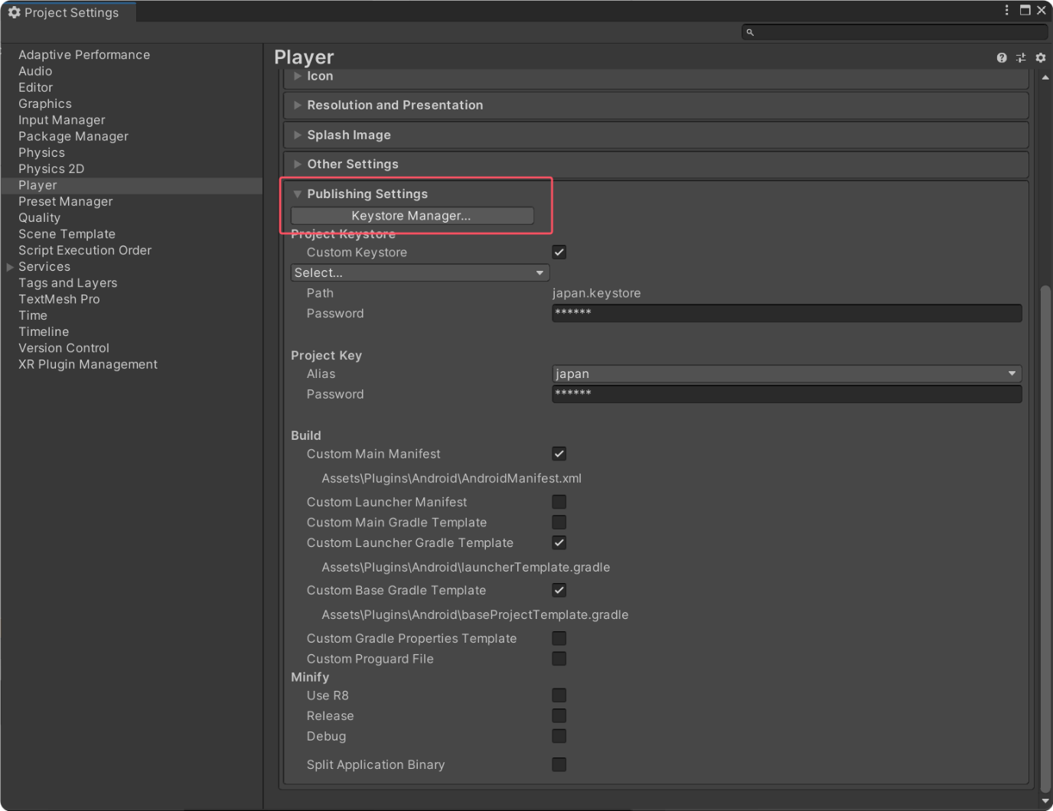

Open the key manager to create your own key (with a .keystore file extension). You can refer to the official documentation: <https://docs.unity3d.com/2020.3/Documentation/Manual/android-keystore-manager.html>.

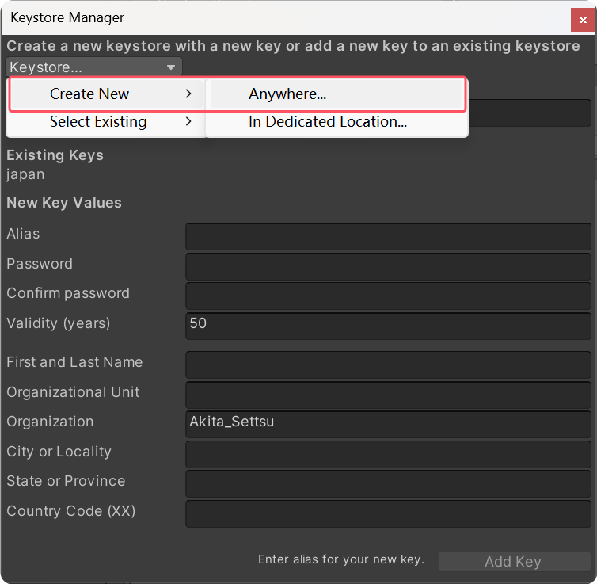

Then select your created key file and enter the password.

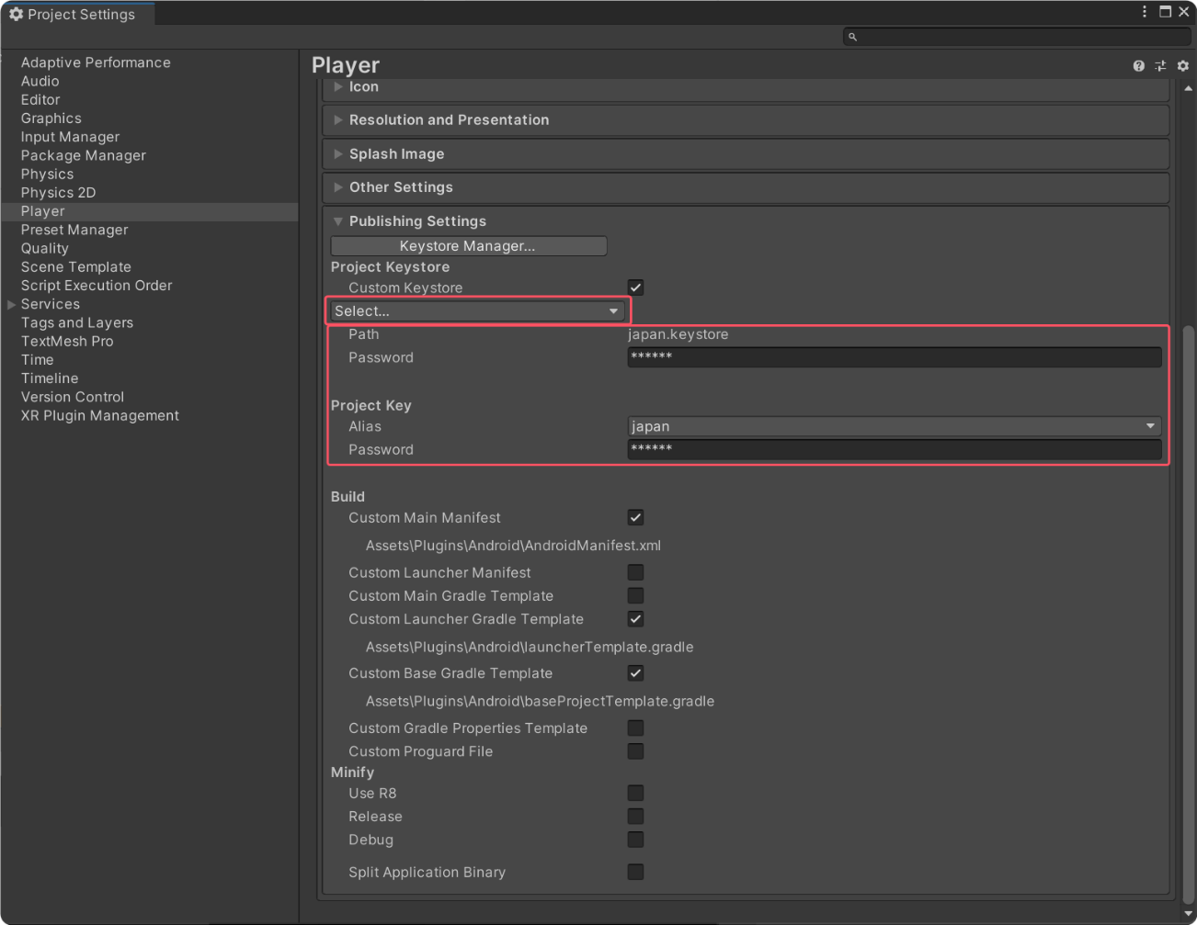

1. **Performing the Packaging**

Remember to add the corresponding three scenes in "Scenes In Build".

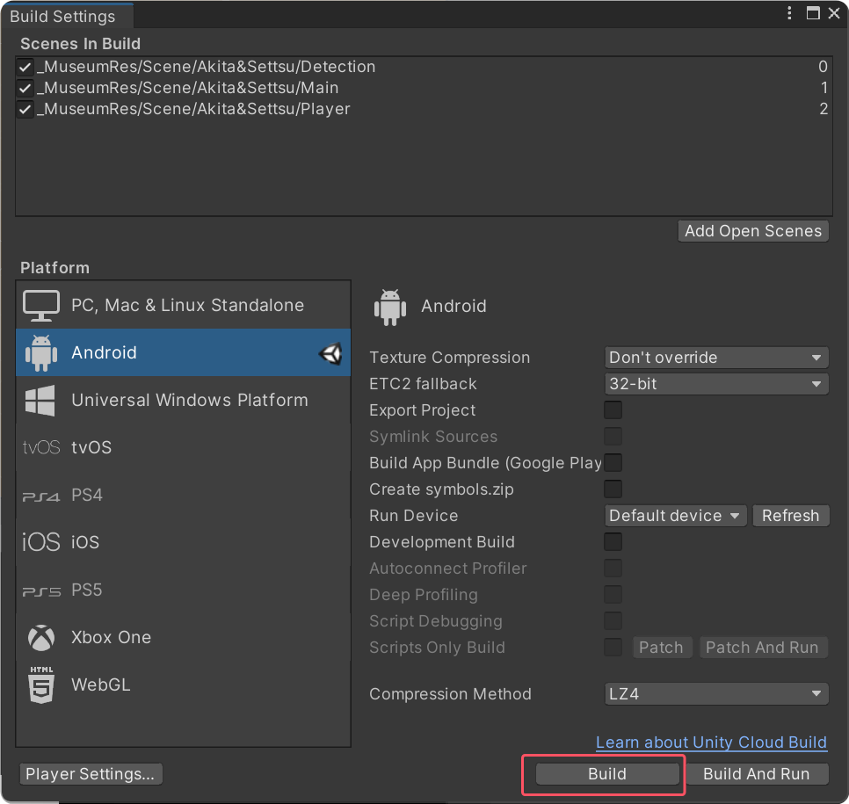

**4. Precautions**

4.1 When packaging for Google, check "Build App Bundle".

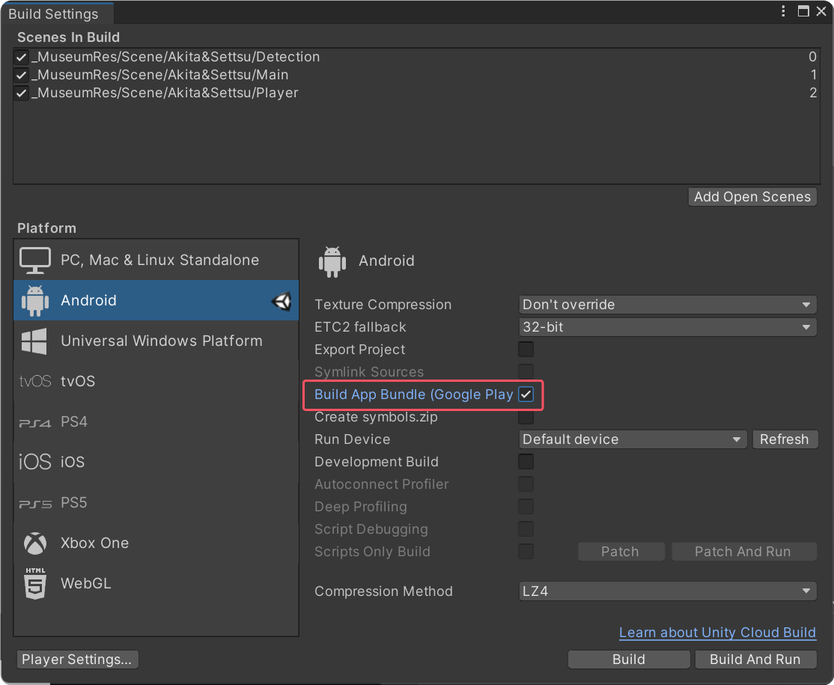

4.2 When packaging multiple times for Google, change the "Bundle Version Code".

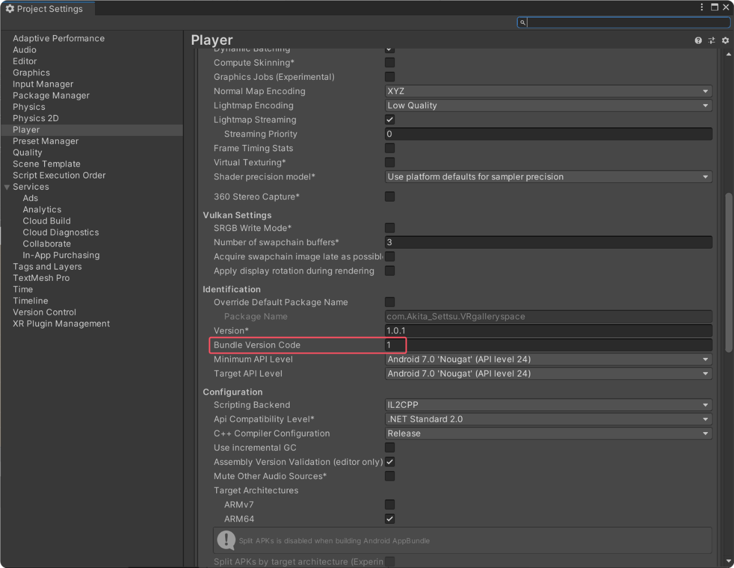

**5. Generating the QR Code**

5.1 Upload the APK in the APP configuration section of the backend.

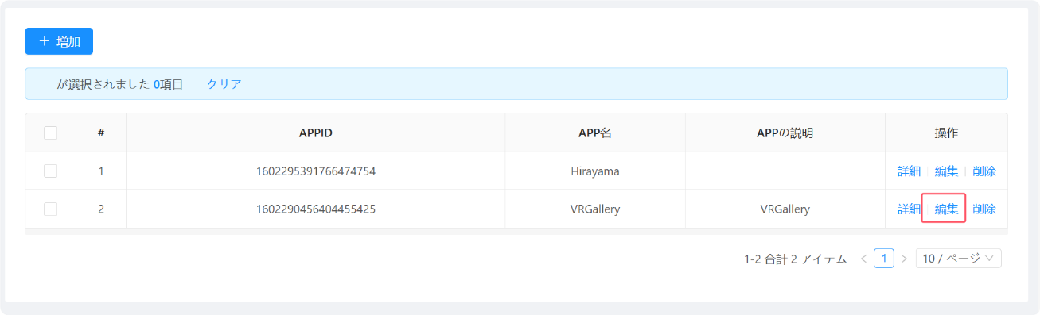

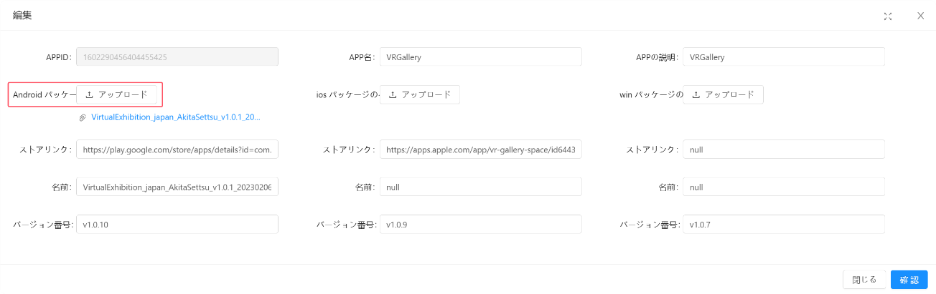

5.2 Then copy the APK address.

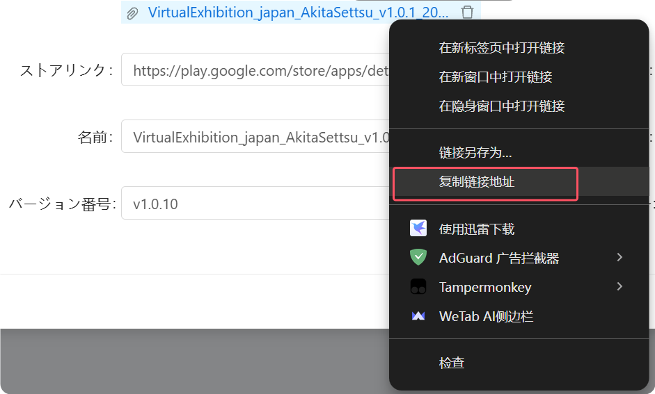

For example: <https://awsjingyi.s3.ap-northeast-1.amazonaws.com/ia/app/appAndroidUrl/VirtualExhibition_japan_AkitaSettsu_v1.0.1_20230206_1675828817556.apk>

5.3 Find a QR code generation website (for example, a Chinese website), generate the QR code, and use it for sharing.

